Order Of Service

Singing: Psalm 67—CW page 91

Reading: Psalm 1

Opening Hymn: TLH 436

Reading: I Corinthians 4:14-21

Request Hymn: CW Supplement 748

Reading: Matthew 26:30-35

Sermon Hymn: TLH 351

Sermon Text: Luke 8:49-56

Give Her Meat

Prayer

The Apostles’ Creed, TLH page 12

Holy Communion

The Lord's Prayer

The Blessing

Closing Hymn: TLH 361

* * * * * * * * * * *

Bible Study: Lambs: Acorn Woodpecker
Sheep: Proverbs 31:10-14
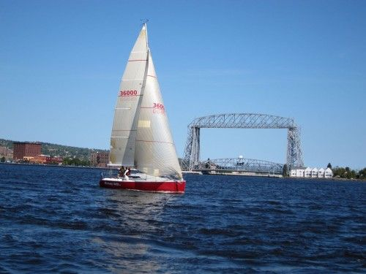

Summer On Lake Superior

Water
Of
Life

15 August 2021

W A T E R O F L I F E

Independent Christian Church—Conservative Lutheran Doctrine

Worship Service: 9:30 a.m. Bible Study: 10:45 a.m.

Larry Cooper, Pastor E-Mail address:
111 N. Ridge Road lcooper@wateroflife.cc
Coon Valley, WI 54623 Web Site:
www.wateroflife.cc

* * * * * * * * * * * * * * * * * * * * * * * * * * *

Sermon Text: Luke 8:49-56

Give Her Meat

* * * * * * * * * * * * * * * * * * * * * * * * * * *

49 While he yet spake, there cometh one from the ruler of the synagogue's house, saying to him, Thy daughter is dead; trouble not the Master.
50 But when Jesus heard it, he answered him, saying, Fear not: believe only, and she shall be made whole.
51 And when he came into the house, he suffered no man to go in, save Peter, and James, and John, and the father and the mother of the maiden.
52 And all wept, and bewailed her: but he said, Weep not; she is not dead, but sleepeth.
53 And they laughed him to scorn, knowing that she was dead.
54 And he put them all out, and took her by the hand, and called, saying, Maid, arise.
55 And her spirit came again, and she arose straightway: and he commanded to give her meat.
56 And her parents were astonished: but he charged them that they should tell no man what was done.

